Performance comparisons among ML models
The data-driven models were meticulously screened to ensure their applicability to this study. In the context of machine learning prediction for the low-velocity impact response of composite materials, Random Forest and Neural Networks are widely recognized as mainstream models. We further conducted a comparative analysis against models like XGBoost, LightGBM, and NN, whose statistical indicators as shown in Table S3, Figs. R2-R5.
Table S3 Comparison of statistical indicators for various response variations across four models
Response variation | Force (F/kN) |  |  | Energy (E/J) |  |  | Displacement (D/mm)
 | R² | MAE | RMSE | R² | MAE | RMSE | R² | MAE | RMSE
RF | 0.986 | 0.0079 | 0.089 | 0.999 | 0.1036 | 0.332 | 0.999 | 0.0532 | 0.231
XGBoost | 0.922 | 0.0448 | 0.269 | 0.967 | 4.7102 | 2.959 | 0.966 | 1.4376 | 1.630
LightGBM | 0.901 | 0.0574 | 0.242 | 0.954 | 6.6255 | 2.582 | 0.953 | 1.9959 | 1.412
NN | 0.961 | 0.0227 | 0.087 | 0.987 | 1.9422 | 0.281 | 0.988 | 0.5328 | 0.189
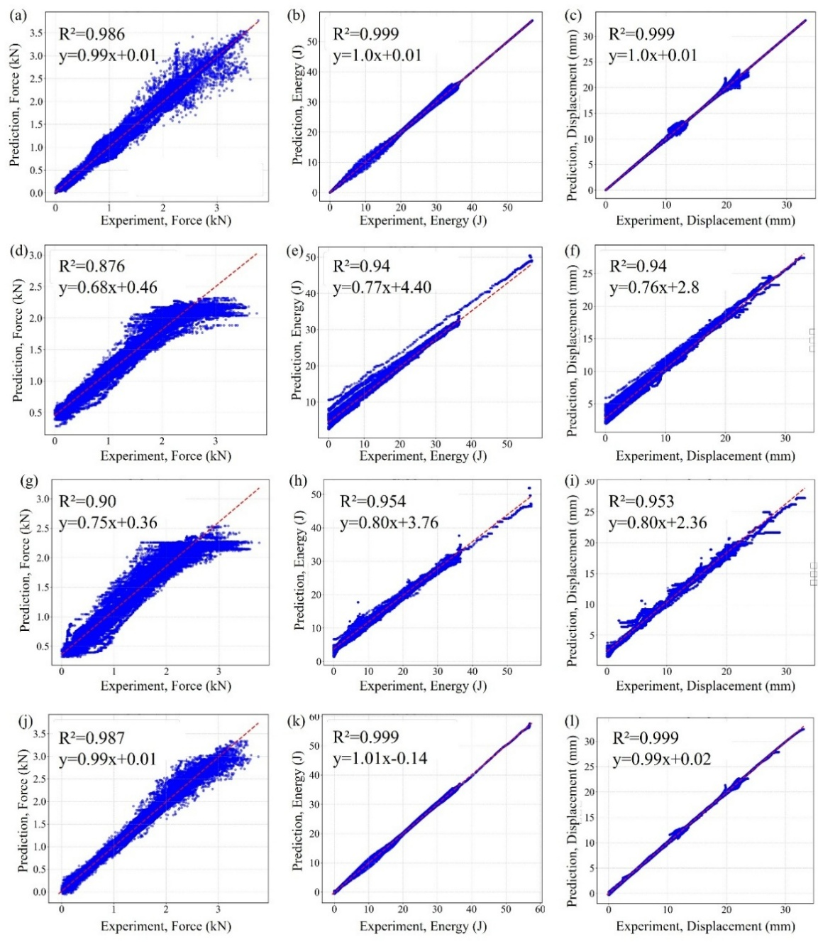
Fig. R2 The predicted results versus the experimental results for (a)-(c) RF, (d)-(f) XGBoost, (g)-(i) LightGBM, and (j)-(l) NN model
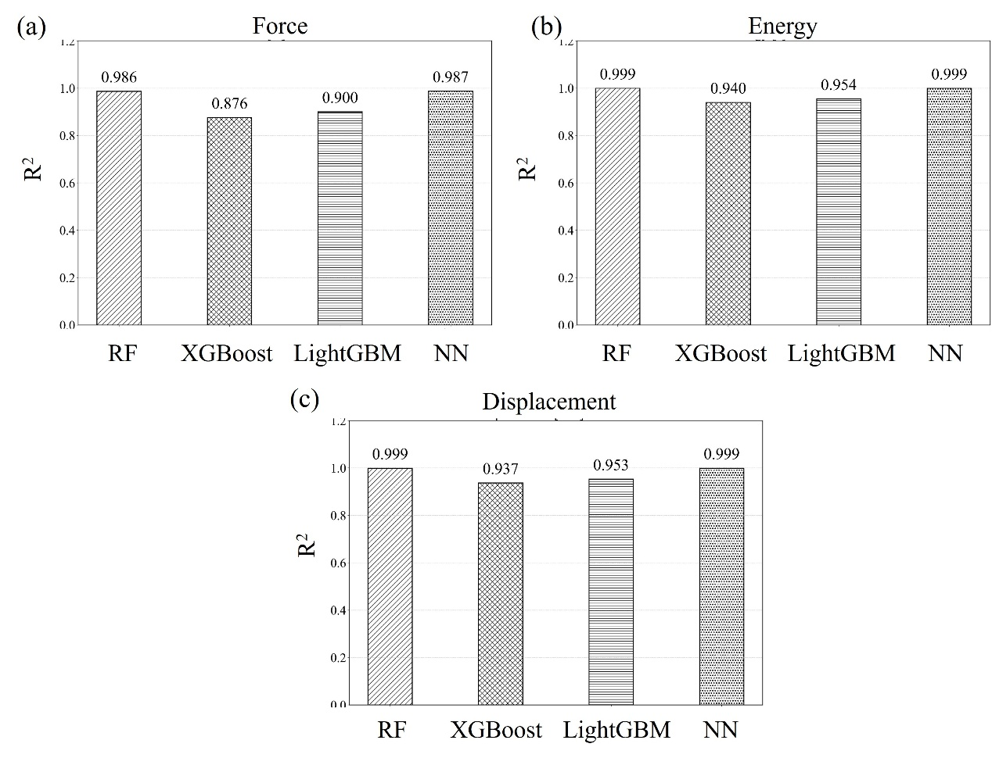
Fig. R3 Comparison of R² for four models
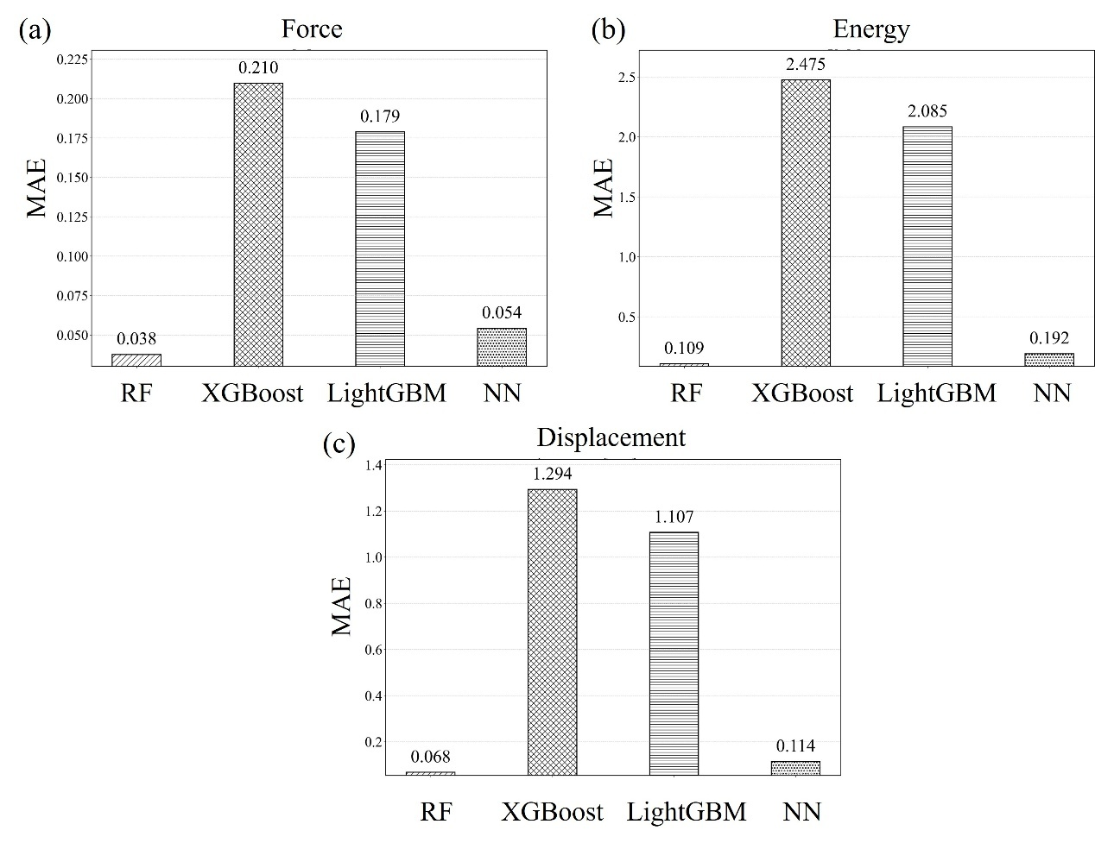
Fig. R4 Comparison of MAE for four models
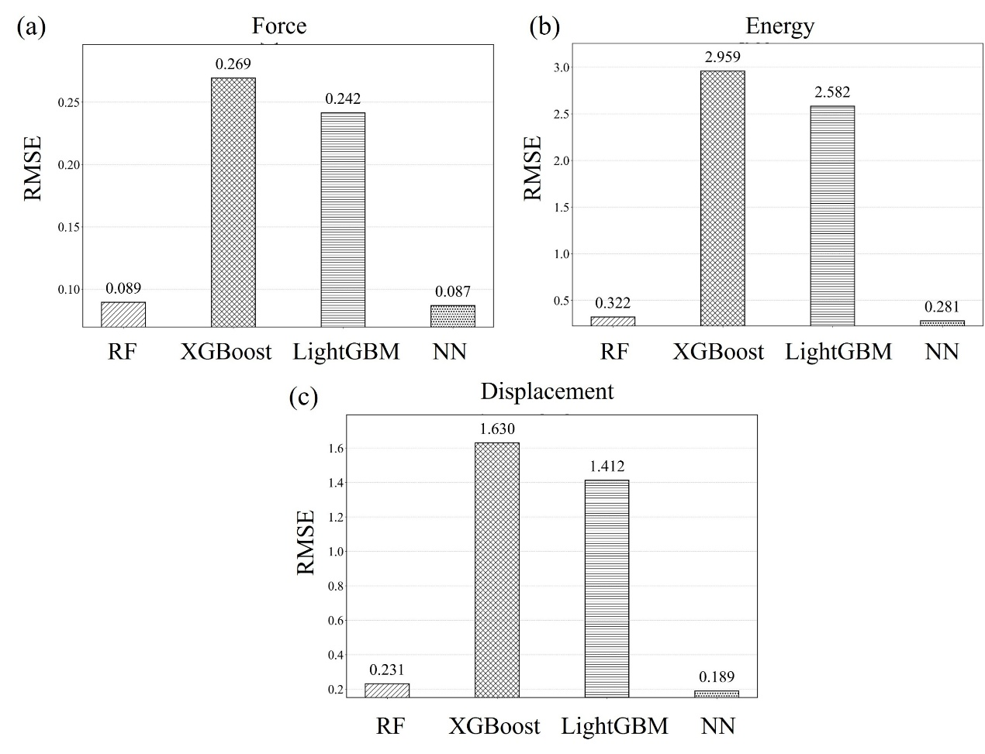
Fig. R5 Comparison of RMSE for four models

We performed hyperparameter tuning using a grid search method to optimize the RF model's performance. The grid search explored a defined parameter space, and the optimal hyperparameters were selected based on lowest validation error and highest R² score. Table R1 presents hyperparameter search space of the RF model as follows.

Table R1 Hyperparameter search space of the RF model
Hyperparameter | Values Explored
number of trees | [150, 200, 250]
maximum depth | [10, 20, None]
minimum samples split | [2]
minimum samples leaf | [1, 2, 3]

Finally, we determined the hyperparameters of the RF model as shown in Table S2 of Supplementary Materials.

Table S4 Hyperparameter of the RF model
Hyperparameter | Value used/default value
mtry | 1.0
sample size | n
replacement | True
node size | 1
number of trees | 200
maximum depth | None
minimum samples split | 2
splitting rule | Mean squared error (MSE)
random state | 42

